Practices for Lesson 9: Configuring Siebel Objects

Practices for Lesson 9

Overview

In these practices, we will you will explore business objects through the Siebel Composer and understand dependencies between objects.

**Practices for Lesson 9-1: Exploring and Customizing Object Definitions using Object explorer**

**Overview**

In this practice, you will explore business objects through the Siebel Composer and understand dependencies between objects.

Assumptions

You should have completed the Practices of Lesson 8.

Tasks

1. Open the WebTools URL and login as Sadmin
2. You will see 2 views. Left Side of pane is Object Navigator whereas the Right side of the Pane is Object List. You will be able to see two views Type and Flat view in object navigator.
3. Exploring columns
4. Select **Business Component** from the left side of the **object navigator**.
5. In the search, choose name from the list and search for **Service Request**.

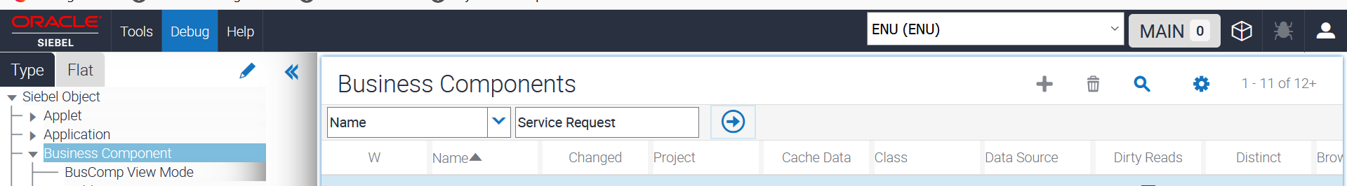

1. Notice that Table = S_SRV_REQ.   
   For seeing this value, you need to scroll in the right side of the pane.

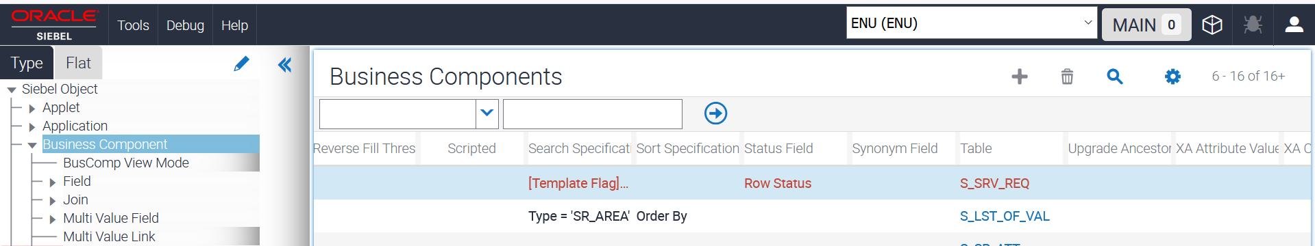  
  
This means that this business component's main or base table is S_SRV_REQ.

1. Now, click on S_SRV_REQ.   
   You are navigated to the Table object definition.
2. In the OE, **expand Table and select Column**. These are the columns that are defined in the Siebel database for this table.
3. In the Columns list, **scroll to the right** through the properties.
4. Remember that the **properties are the column headings**.
5. Notice that there are properties such as **Required, Physical Type, Default** and so on.
6. Make sure the **Columns list is the active applet.**

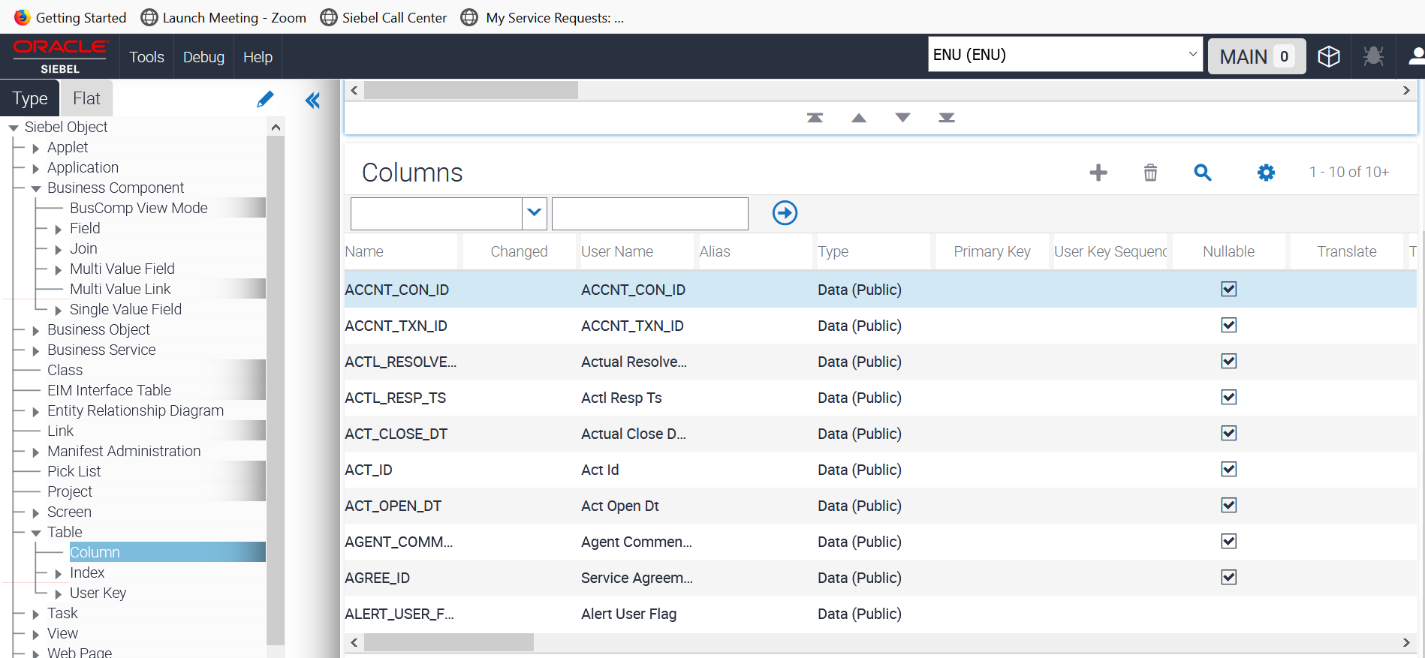

1. Start a new query
2. In the column list, choose the **Type** in the Column and Enter the value as **System**. Run the query. These are all columns that are automatically maintained by the application.

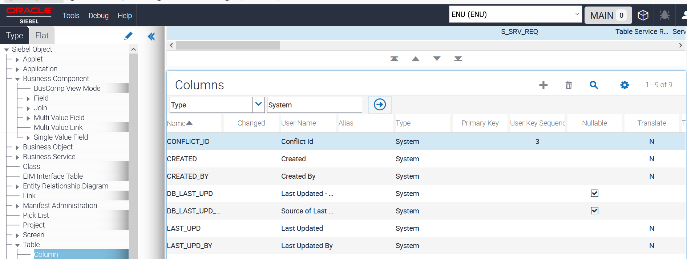

1. Run a new query. Click on **Settings icon under the columns list** and choose **new query**.

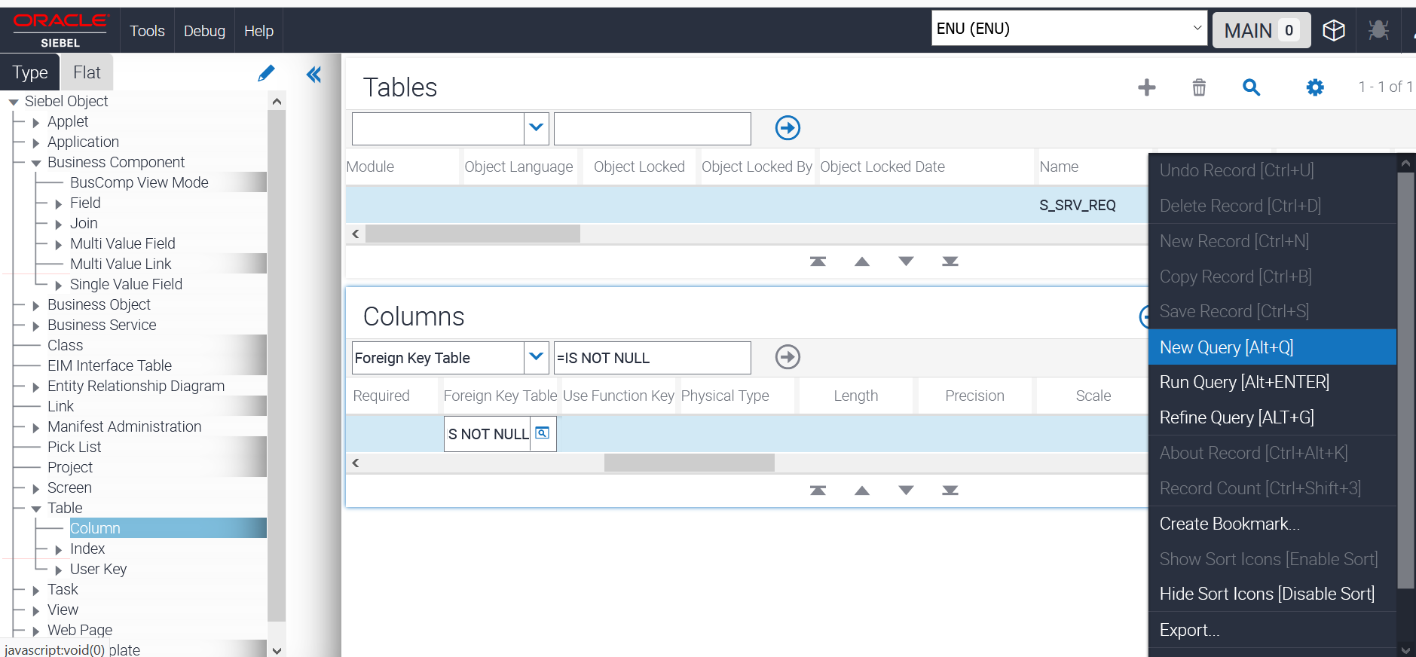

1. Under the column **Foreign Key Table = IS NOT NULL. Click on search icon** available in the column.  
   Note: Although this is a picklist, you can type into the column.
2. You will see many rows displayed. Each of these columns is a foreign key to another table. These are used to maintain the relationships (1:M and so on) in the data model.

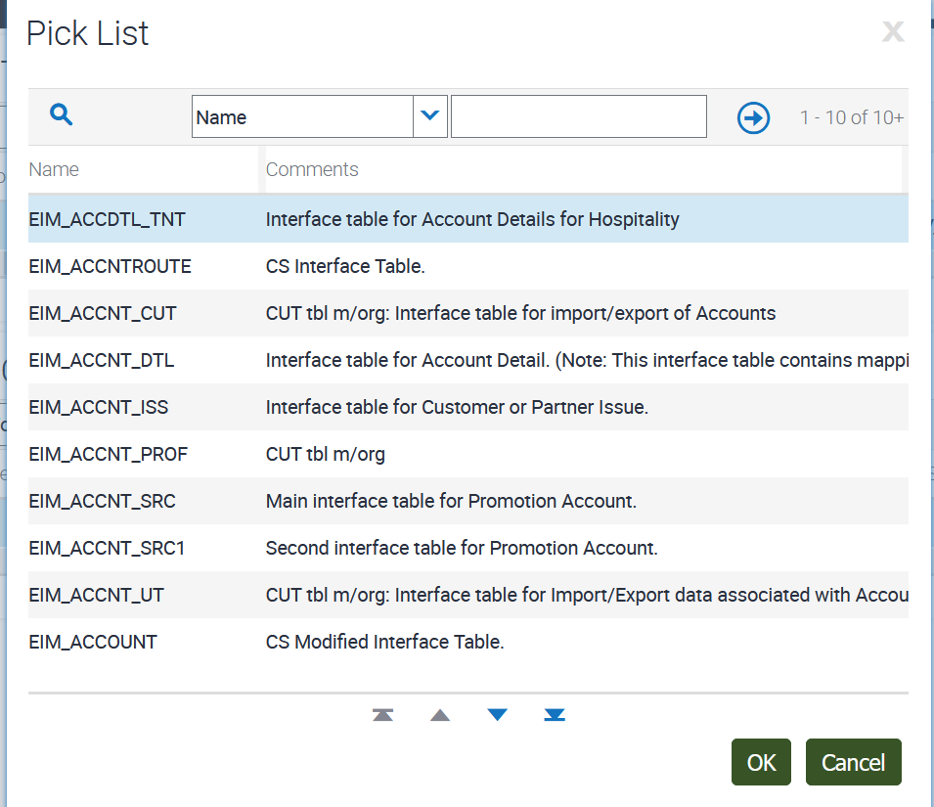

1. Click **Cancel**.
2. Exploring advanced object definitions.
   1. Explore additional object types.
3. Continue in Object explorer.
4. Scroll down and locate Table.
5. Double **click on Table**.

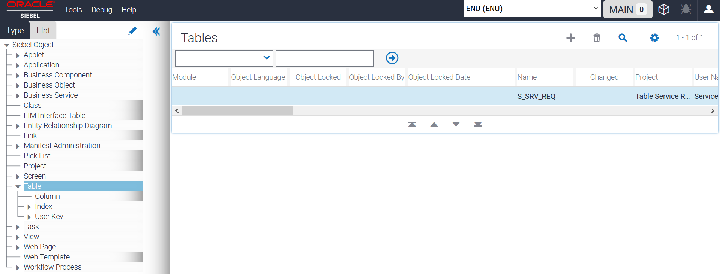

* 1. Exploring user keys.

1. Choose Column as Name and Table Name : S_SRV_REQ

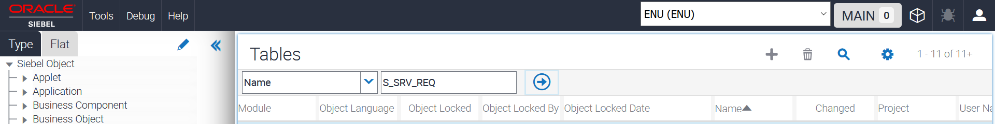

1. Select Table :: S_SRV_REQ.   
   This means, to query for Table with Name = S_SRV_REQ, you can use Columns Displayed to position the Name to the left of the list.
2. In the OE, expand **Table and click User Key**.
3. Verify that there is one user key S_SRV_REQ_U1.
4. In the OE, **expand User Key and click User Key Column**. This shows the columns that make up the user key.

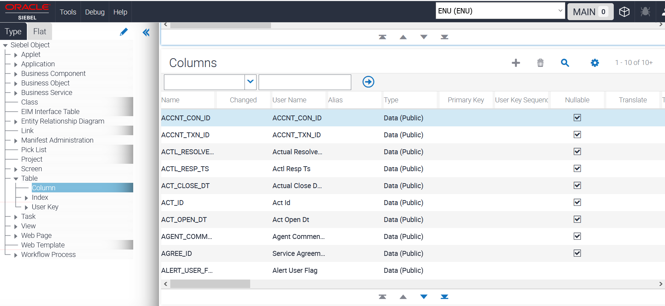

1. Exploring indexes
   1. In the OE, **click Index.**
   2. Verify that there are many indexes defined.
   3. In the bottom applet, query for Name = *U. This is the index that supports the user key.

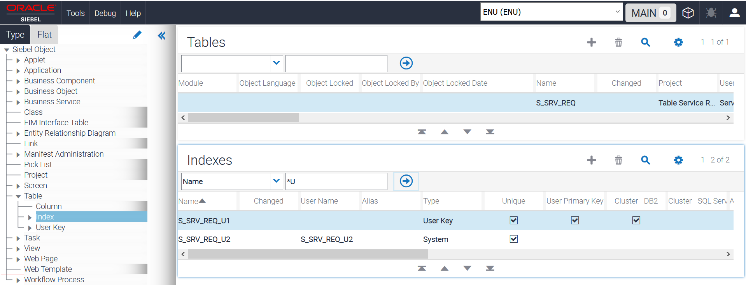

* 1. In the OE, expand Index and click Index Column. These are the columns that make up this index.
  2. In the top applet, query for Name = *P1. This is the index that supports the primary key.

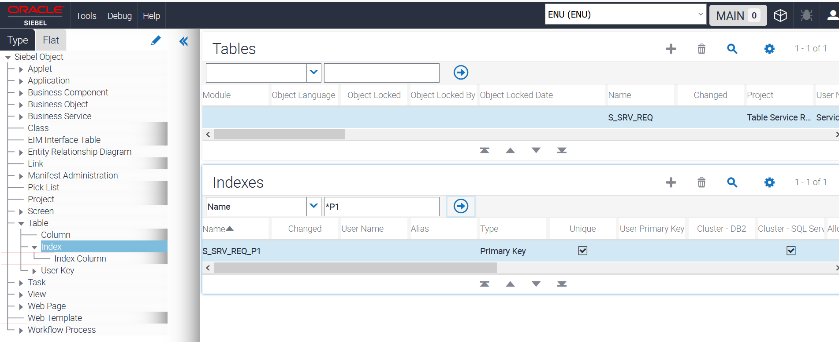

* 1. Verify that the index is based on the specific column displayed.

1. Exploring extension tables**.**
2. Select Table :: S_SRV_REQ_X. This is 1:1 extension table for Service Requests.

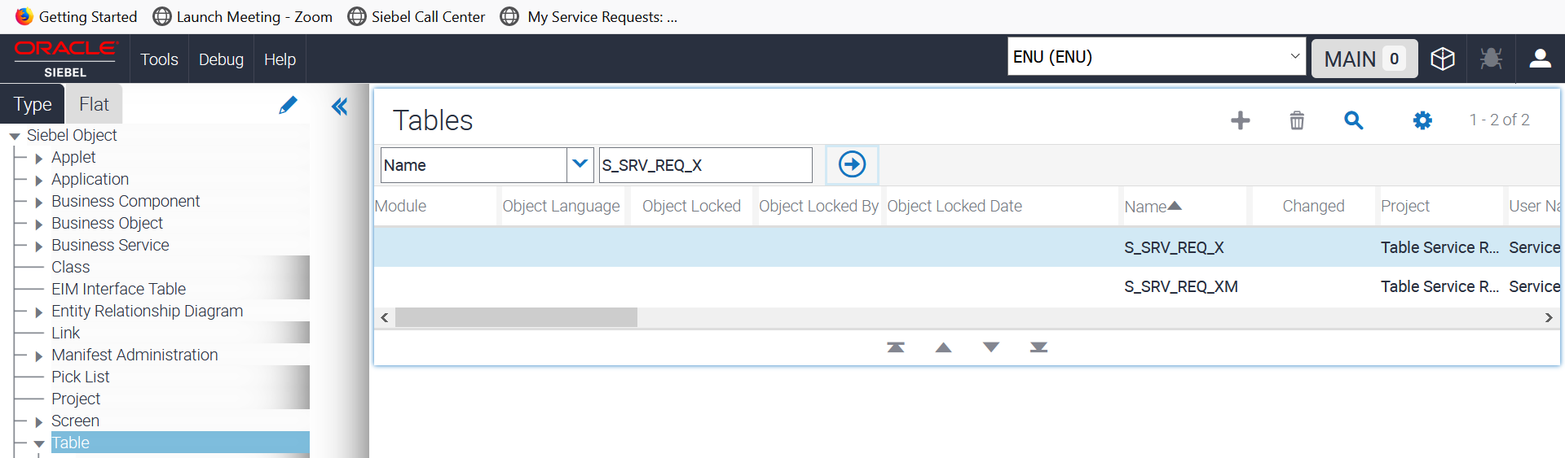

1. In the OE**, click Column**.
2. Verify that there are many ATTRIB columns. These are available to store additional data elements.   
   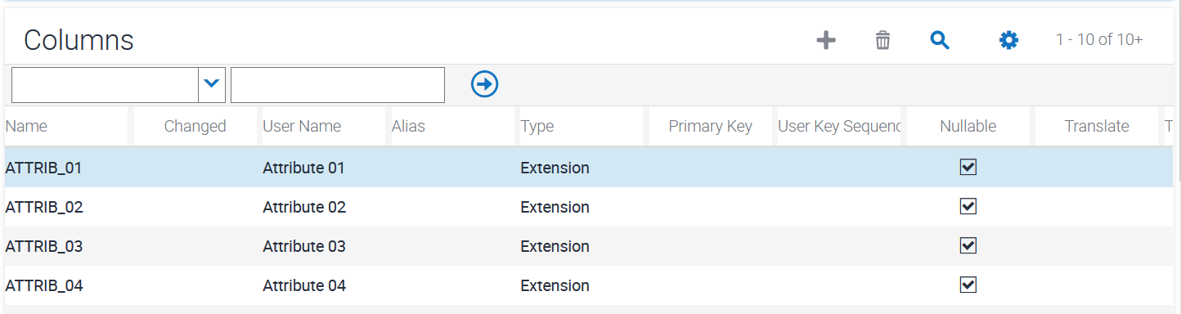
3. Select Table :: S_SRV_REQ_XM. This is 1:M extension table for Service Requests.

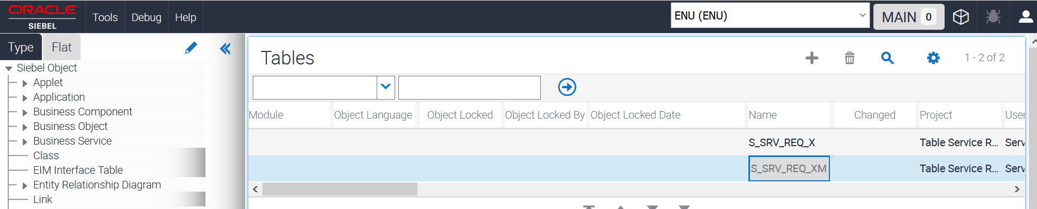

1. In the OE, click **Column**.
2. Verify that it also has many ATTRIB columns.
3. In the bottom applet, query for Required = TRUE (checked).

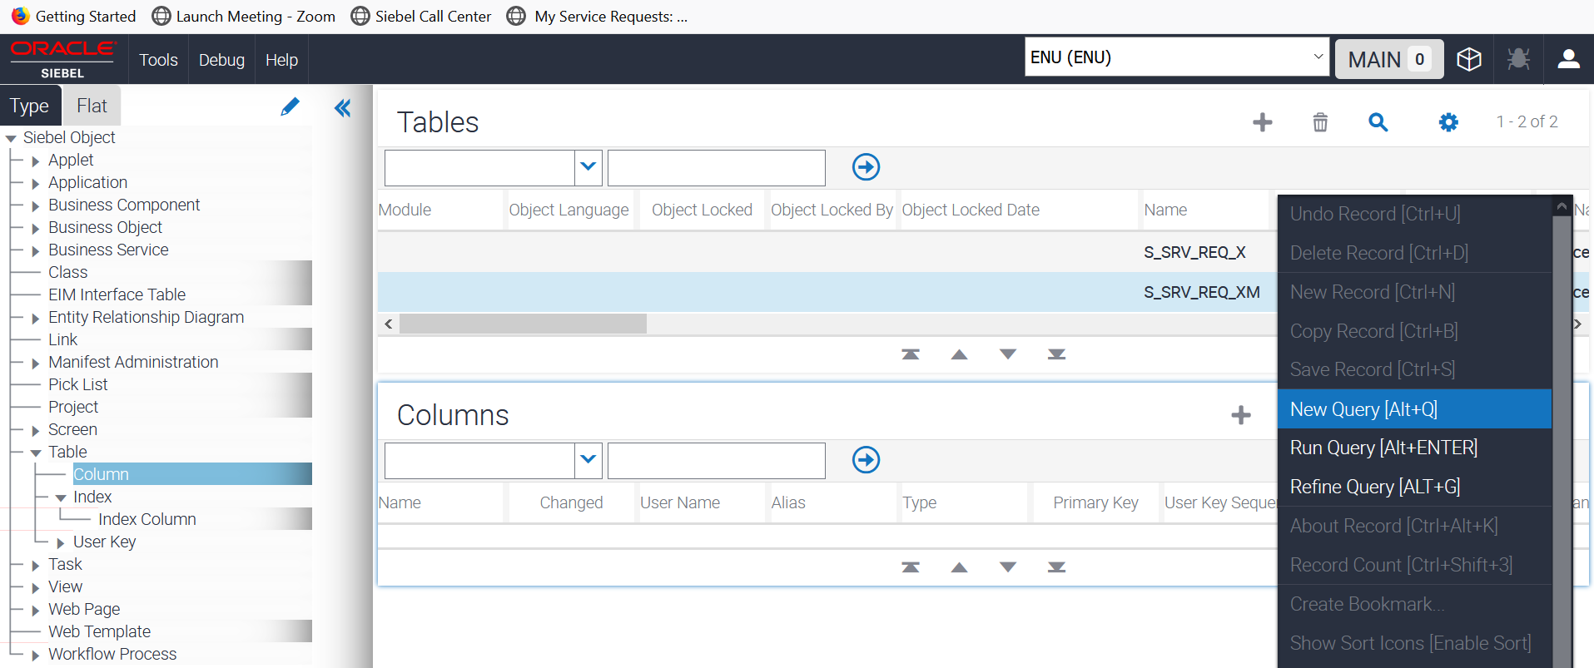

1. Now, click **Run Query (🡪)**

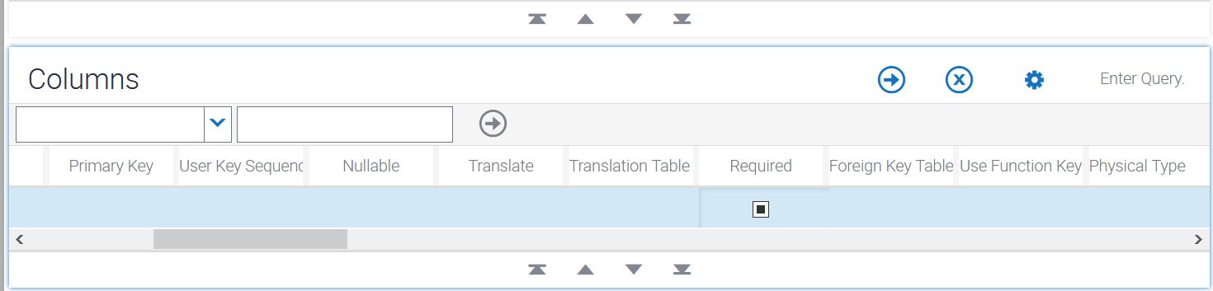

1. Note that some of the columns have values in the Default property.

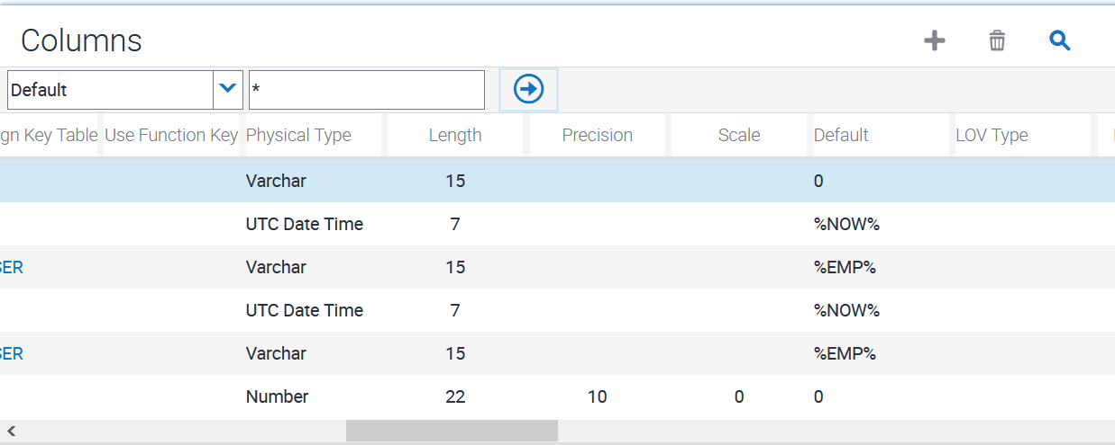

1. Exploring links
   1. In the OE, **click Link.**
   2. **Start a new query**.
   3. Set **Name = Service Request/\*** and Inter Table = IS NOT NULL.

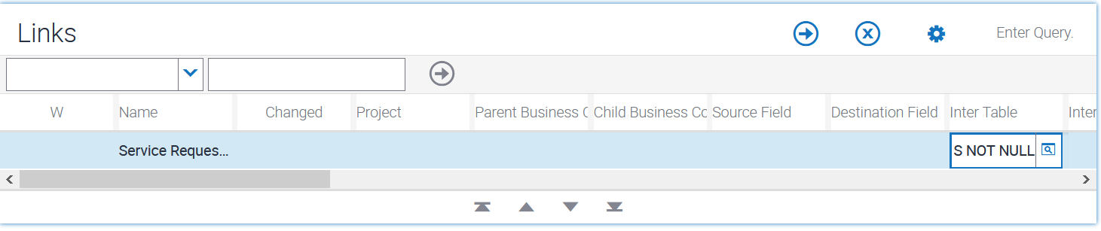

* 1. Run the query.
  2. Select the record with Name = Service Request/Contacts. Recall that links define relationships between business components.



* 1. Verify that the Parent Business Component property is set to **Service Request** and Child Business Component property is set to **Contact**.
  2. Notice that the Inter Table property is set to S_SR_CONTACT. When this properly is not blank, it means that the relationship between the business components is a many-to-many (M:M) relationship.

1. Exploring intersection tables

**Note**: Continue in Links section.

1. Drill down on the Inter Table property **(**S_SR_CONTACT).

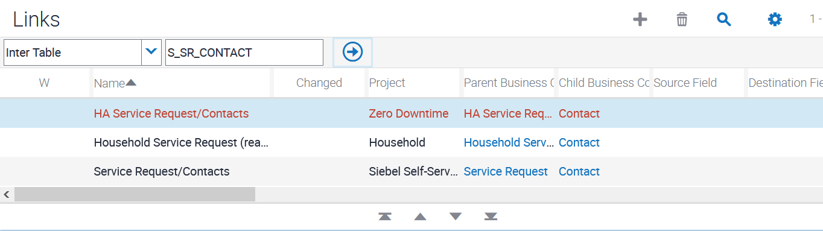

1. In the OE, click **Column.**
2. In the bottom applet, query for **Foreign Key Table = IS NOT NULL.**

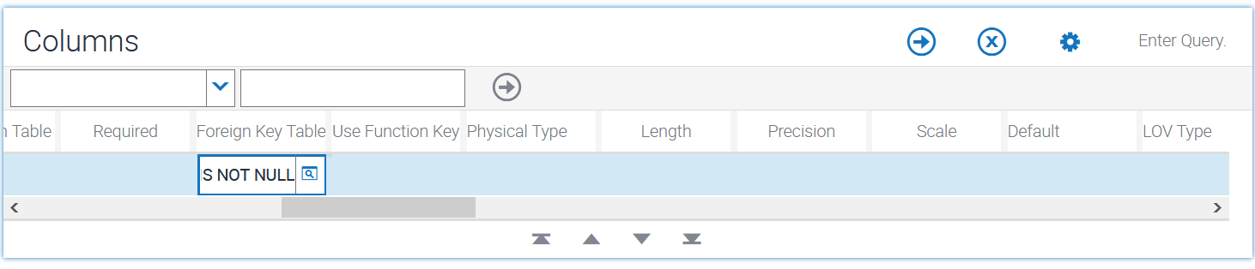

1. Verify the foreign key.
2. Close the Object Explorer by closing browser window.